# Summary

The Office of Law and Enforcement and Security (OLES) Technology Division is an internal service provider tasked with providing information technology and supporting the Law Enforcement agencies within the Department of Interior. In support of the IMARS program, the Technology Division has launched the Law Enforcement Portal based on SharePoint. One of the major Challenges that the Technology Division team faces is that they are dependent on the Department of Interior Office of the Chief Information Officer (OCIO) to provide services and infrastructure to support the Portal. Trident Professional Services proposes to build a SharePoint Portal that is:

* More Flexible
* More Secure
* More Cost Effective

We accomplish this by eliminating the legacy on-premises infrastructure provided by the OCIO and eliminating the OCIO’s operational overhead.





# Migration

WHAT IS A DATA MIGRATION

Migration is the process of copying SharePoint content and customizations to a different SharePoint farm or location within SharePoint. Utilizing the cloud will allow the OLES Technology division to outsource much of the administration burden to a cloud provider at a lower cost then is possible with OCIO and allow rapid reconfiguration of resources, which is not currently possible.

UNDERSTANDING BEST PRACTICES TO IMPROVE THE MIGRATION PROCESS

The ability to test the migration process is critical from a risk management perspective. The mantra “test early and test often” should be followed during any complicated project. Migration options that do not allow testing to be performed in advance are likely to suffer from much more serious issues than those where problems can be found quickly and worked out.

In addition to general migration testing, it is important to create a test plan that also takes into account the following variables: Custom code that needs to be ported, such as Custom list templates; Custom site templates, such as Custom web parts or Third-party web parts; Feature mapping, including deprecated features, such as SPS portal listings. From a logistical perspective, planning for a test migration typically involves the creation of a designated test environment.

to is

PRE-MIGRATION CHECKLIST

* PLANNING FOR A SHAREPOINT MIGRATION OR UPGRADE (Inventory of data at current location)

The migration process gives organizations an ideal opportunity to re-architect and restructure the information architecture. A clear understanding of what content currently exists across an organization and what content should be migrated into SharePoint is vital to the success of a migration project. The existing information architecture and taxonomy of the organization’s systems should also be audited.

This planning includes documenting and auditing the following key areas:

* Permissions
* SharePoint Customizations (including custom code)
* Integration with other systems

The plan should also make it clear who the key personnel contacts will be for each facet of the migration and how each facet will be planned, handled and tested. SharePoint 2016 and SharePoint Online allow for much more sophisticated information architecture than was possible in previous versions or in other systems.

* PREPARE AN INFORMATION ARCHITECTURE PLAN (Organizing and labeling data)

SharePoint taxonomy is a particularly interesting consideration for organizations migrating or upgrading to SharePoint Online. Long-term information architecture governance can help to improve this scenario and result in content being better organized and searchable. Migrations that simply dump data into a loosely defined structure or migrate into existing data structures are often considered failures because they lack any type of defined governance plan and often suffer from low adoption rates as users can’t easily find the data they need.

* PREPARE A MIGRATION TEST PLAN (How will data be moved into new location)

in the existing platform, as part of a document workflow process or as a method of displaying critical data in a particular.

In addition to the test environment, the test plan should always include a User Acceptance Testing (UAT) phase, which allows users to test the migrated data in the new environment themselves before it is accepted as production data. A UAT allows for issues to be identified and for the migration process itself to be fully vetted in advance. Ideally, the UAT users should be chosen from a subset of the members across an organization to ensure they properly represent the type of users expected in the system.

After a plan has been created, information governance plans are enacted, and the migration process has been tested, the process of migrating content from source to the target can commence.

FACTORS TO CONSIDER TO FACILIATE MIGRATION

* CONSIDER SHAREPOINT CUSTOMIZATIONS AND INTEGRATION
* USING THE MICROSOFT DATABASE ATTACH UPGRADE or USING THIRD-PARTY MIGRATION PRODUCTS

POST-MIGRATION CHECKLIST (Verifying all the data was moved)

After a migration has taken place, a key to the success of the project is the verification of the migrated content in the new environment. The ability to compare the source and target environments is critical, particularly when troubleshooting whether a document successfully made it to the new platform.

## Customization Migration

SharePoint customizations will need to be updated to be used in SharePoint Online. Customization of SharePoint 2016 takes two forms:

* Branding
* Applications

### Branding

Existing SharePoint Branding is based SharePoint publishing and custom master pages. None of the existing branding will be usable in SharePoint Online and must be transitioned to SharePoint Framework Extensions and Modern Pages.

#### Content

Publishing Page layouts will not be available, so labor will need to be allocated to using modern pages to replace layouts utilized across the site collections.

### Applications

Existing web parts and custom functionality will need to be moved to SharePoint Framework Web Parts. Existing code will most likely still be useful, but deployment and packaging would need to be updated for use with SharePoint Online as well as time to test the code to prevent regression.

### 

# Establish Product Development Pipeline

Once the existing SharePoint content and customization has been migrated to a stable platform the next step is to establish a product development pipeline that delivers a steady stream of new features and bug fixes to the OLES Technology Division and clients. The general process will follow this outline.

1. Design
   1. New features and bugs will need to be prioritized with product owners from the client
   2. Product owners will need to coordinate with the OLES Technology Division leadership to establish budget.
   3. Trident Professional Services will coordinate with the SharePoint Architect and Creative Director to design and document solutions for each feature or bug.
   4. Tasks will be generated from the documented solutions
   5. Each task will receive a difficulty score.
   6. Using past performances Trident Professional Services will provide rough estimates of delivery time frames
   7. OLES Technology Division leadership will provide final approval for design
2. Develop
   1. Work will be performed in two-week sprints until the product back log is empty or OLES Technology Division leadership instructs Trident Professional Services to end development work
3. Deliver
   1. Trident Professional Services will utilize continuous integration to deploy completed code to production.
      1. Code will be developed and tested in SharePoint Online Developer tenants
      2. Checked in Code will be immediately incorporated into staging SharePoint site collections that are isolated from production
      3. Product owners and selected testers will test applications in the staging areas
      4. Code approved by Product Owners will be moved to production at the end of the two-week cycle
4. Review
   1. Trident Professional Services staff will update the documentation to reflect changes made during development as well as writing end user documentation
5. Return to step 1.

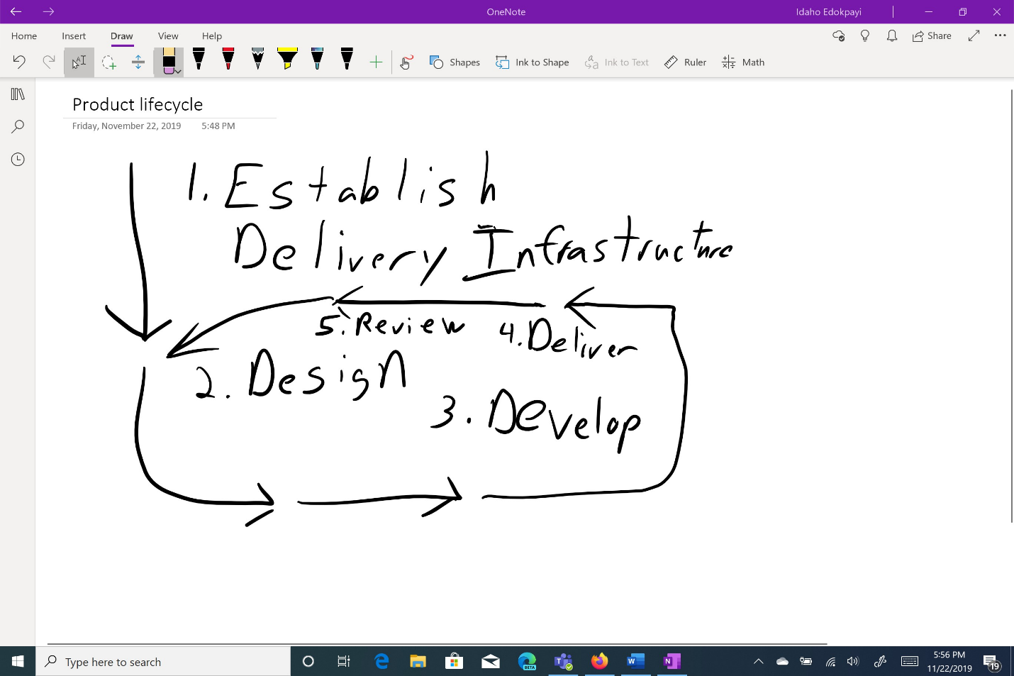

# Trusted Advisors

In addition to running the portal, Trident Professional Services, will work with the OLES Technology Division to advocate for adoption of the platform and help provide training for end users. Trident Professional Services hopes to become trusted advisors working with OLES Technology Division on IT strategy and utilization of technology. OLES Technology Division derives it’s budget from the member bureaus of the Department of Interior and Trident Professional Services will provide written materials and other support to aid in obtaining that.